

CSE 1004

Network and Communication

LAB ASSessment - 5

**NAME**: Vibhu Kumar Singh

**REG. NO**: 19BCE0215

**TEACHER**: Santhi H.

**Q1) Write a program to perform exchange of any text message between server and client and vice versa using TCP Application.**

**Ans 1)**

**Aim:** To perform exchange of any text message between server and client and vice versa using TCP Application.

**Algorithm:**

**Server Side Algorithm:**

STEP 1: Start

STEP 2: Declare the variables for the socket

STEP 3: Specify the family, protocol, IP address and port number

STEP 4: Create a socket using socket() function

STEP 5: Bind the IP address and Port number

STEP 6: Listen and accept the client’s request for the connection

STEP 7: Read the client’s message

STEP 8: Display the client’s message

STEP 9: Continue the chat

STEP 10: Terminate the chat

STEP 11: Close the socket

STEP 12: Stop

**Client Side Algorithm:**

STEP 1: Start

STEP 2: Declare the variables for the socket

STEP 3: Specify the family, protocol, IP address and port number

STEP 4: Create a socket using socket() function

STEP 5: Call the connect() function

STEP 6: Read the input message

STEP 7: Send the input message to the server

STEP 8: Display the server’s reply

STEP 9: Continue the chat

STEP 10: Terminate the chat

STEP 11: Close the socket

STEP 12: Stop

Functions used here are:

System calls that allow to access the network functionality of a Unix box are as given below. When you call one of these functions, the kernel takes over and does all the work for you automatically.

Server Side:

socket () bind() connect() listen() accept() send() recv() close()

Client Side:

socket () gethostbyname() connect() send() recv() close()

**Source Code:**

**Q1Server.c**

#include<sys/socket.h>

#include<stdio.h>

#include<string.h>

#include<netdb.h>

#include<stdlib.h>

**int** main()

{

**char** buf[100];

**int** k;

    socklen_t len;

**int** sock_desc,temp_sock_desc;

**struct** sockaddr_in server,client;

    memset(&server,0,sizeof(server));

    memset(&client,0,sizeof(client));

    sock_desc=socket(AF_INET,SOCK_STREAM,0);

    if(sock_desc==-1)

    {

        printf("Error in socket creation");

        exit(1);

    }

    server.sin_family=AF_INET;

    server.sin_addr.s_addr=inet_addr("127.0.0.1");

    server.sin_port=3002;

    k=bind(sock_desc,(**struct** sockaddr*)&server,sizeof(server));

    if(k==-1){

        printf("Error in binding");

        exit(1);

    }

    k=listen(sock_desc,20);

    if(k==-1)

    {

        printf("Error in listening");

        exit(1);

    }

    len=sizeof(client);

    temp_sock_desc=accept(sock_desc,(**struct** sockaddr*)&client,&len);

    if(temp_sock_desc==-1)

    {

        printf("Error in temporary socket creation");

        exit(1);

    }

    while(1)

    {

        k=recv(temp_sock_desc,buf,100,0);

        if(k==-1)

        {

            printf("Error in receiving");

            exit(1);

        }

        printf("Message got from client is : %s",buf);

        printf("\nEnter data to be send to client: ");

        fgets(buf,100,stdin);

        if(strncmp(buf,"end",3)==0)

        break;

        k=send(temp_sock_desc,buf,100,0);

        if(k==-1)

        {

            printf("Error in sending");

            exit(1);

        }

    }

    close(temp_sock_desc);

    exit(0);

    return 0;

}

**Q1Client.c**

#include<sys/socket.h>

#include<stdio.h>

#include<string.h>

#include<netdb.h>

#include<stdlib.h>

**int** main()

{

**char** buf[100];

**int** k;

**int** sock_desc;

**struct** sockaddr_in client;

    memset(&client,0,sizeof(client));

    sock_desc=socket(AF_INET,SOCK_STREAM,0);

    if(sock_desc==-1)

    {

        printf("Error in socket creation");

        exit(1);

    }

    client.sin_family=AF_INET;

    client.sin_addr.s_addr=INADDR_ANY;

    client.sin_port=3002;

    k=connect(sock_desc,(**struct** sockaddr*)&client,sizeof(client));

    if(k==-1)

    {

        printf("Error in connecting to server");

        exit(1);

    }

    while(1)

    {

        printf("\nEnter data to be send to server: ");

        fgets(buf,100,stdin);

        if(strncmp(buf,"end",3)==0)*//Use "end" to end communication with server*

            break;

        k=send(sock_desc,buf,100,0);

        if(k==-1)

        {

            printf("Error in sending");

            exit(1);

        }

        k=recv(sock_desc,buf,100,0);

        if(k==-1)

        {

            printf("Error in receiving");

            exit(1);

        }

        printf("Message got from server is : %s",buf);

    }

    close(sock_desc);

    exit(0);

    return 0;

}

**OUTPUT SCREENSHOTS:**

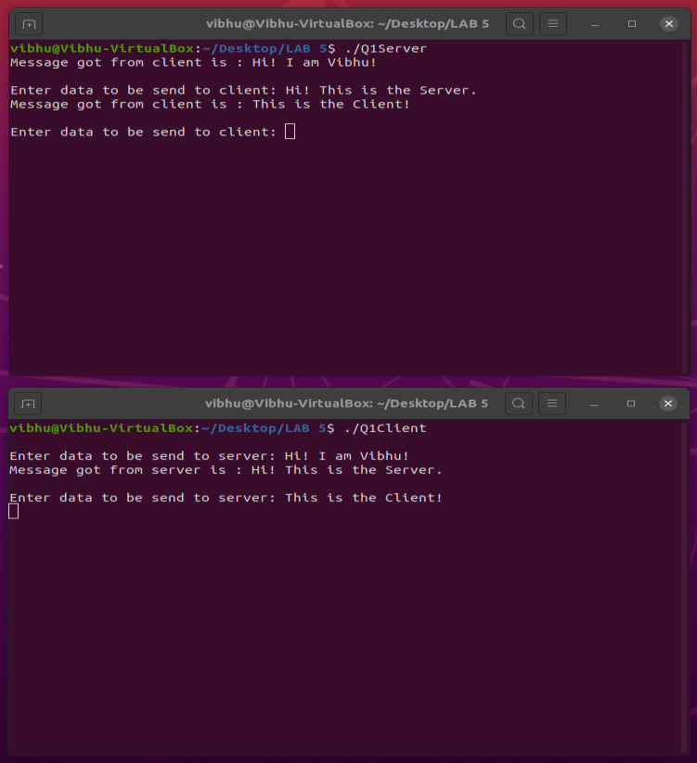

**Q2) Write a program to display the server’s date and time details at the client end.**

**Ans 2)**

**Aim:** To display the server’s date and time details at the client end.

**Algorithm:**

**Server Side Algorithm**

STEP 1: Start the program.

STEP 2: Declare the variables and structure for the socket..How to Find Day Time Server to Client Source code in C Programming

STEP 3: The socket is binded at the specified port.

STEP 4: Using the object the port and address are declared.

STEP 5: The listen and accept functions are executed.

STEP 6: If the binding is successful it waits for client request.

STEP 7: Execute the client program.

**Client Side Algorithm**

STEP 1: Start the program.

STEP 2: Declare the variables and structure.

STEP 3: Socket us created and connect function is executed.

STEP 4: If the connection is successful then server sends the message.

STEP 5: The date and time is printed at the client side.

STEP 6: Stop the program.

**Source Code:**

**Q2Server.c**

#include <stdio.h>

#include <unistd.h>

#include <time.h>

#include <errno.h>

#include <string.h>

#include <stdlib.h>

#include <sys/types.h>

#include <sys/wait.h>

#include <sys/socket.h>

#include <netinet/in.h>

#include <arpa/inet.h>

#include <netdb.h>

#define MY_PORT_NUMBER 49999

**int** main(**int** argc, **char** **argv) {

**int** listenfd;

    if ((listenfd = socket(AF_INET, SOCK_STREAM, 0)) < 0)

    {

        perror("socket");

        exit(1);

    }

    printf("Server socket created\n");

**struct** sockaddr_in servAddr;

    memset(&servAddr, 0, sizeof(servAddr));

    servAddr.sin_family = AF_INET;

    servAddr.sin_port = htons(MY_PORT_NUMBER);

    servAddr.sin_addr.s_addr = htonl(INADDR_ANY);

    if (bind(listenfd, (**struct** sockaddr *)&servAddr, sizeof(servAddr)) < 0)

    {

        perror("bind");

        exit(1);

    }

    printf("Socket bound to port\n");

    if ((listen(listenfd, 1)) < 0)

    {

        perror("listen");

        exit(1);

    }

    printf("Listening for connections...\n\n");

**int** connectfd, status;

**int** length = sizeof(**struct** sockaddr_in);

**struct** sockaddr_in clientAddr;

    while (1) {

        if ((connectfd = accept(listenfd, (**struct** sockaddr *)&clientAddr, &length)) < 0) {

            perror("accept");

            exit(1);

        }

        printf("Client connection found!\n");

        if (fork()) {

            close(connectfd);

            waitpid(-1, &status, 0);

        }

        else {

**struct** hostent *hostEntry;

**char** *hostName;

            if ((hostEntry = gethostbyaddr(&(clientAddr.sin_addr), sizeof(**struct** in_addr), AF_INET)) == NULL) {

                herror("gethostbyaddr");

                exit(1);

            }

            hostName = hostEntry->h_name;

            printf("Connected to: %s\n", hostName);

**char** buffer[100];

**time_t** ltime;

            time(&ltime);

            strcpy(buffer, ctime(&ltime));

**int** len = strlen(buffer);

            buffer[len] = '\0';

            if ((write(connectfd, buffer, 100)) <= 0) {

                perror("write");

                exit(1);

            }

            printf("Wrote time and date to client\n");

            printf("%s exiting...\n\n", hostName);

            close(connectfd);

            exit(0);

        }

    }

}

**Q2Client.c**

#include <stdio.h>

#include <stdlib.h>

#include <unistd.h>

#include <string.h>

#include <sys/types.h>

#include <sys/socket.h>

#include <netinet/in.h>

#include <arpa/inet.h>

#include <netdb.h>

#define MY_PORT_NUMBER 49999

**int** main(**int** argc, **char** **argv) {

    if(argc < 2) {

        printf("Invalid connection format, format is: <executable> <hostname/address>\n");

        exit(1);

    }

**int** socketfd;

    if( (socketfd = socket( AF_INET, SOCK_STREAM, 0)) < 0) {        perror("socket");

        exit(1);

    }

**struct** sockaddr_in servAddr;

**struct** hostent *hostEntry;

**struct** in_addr **pptr;

    memset(&servAddr, 0,sizeof(servAddr));

    servAddr.sin_family = AF_INET;

    servAddr.sin_port = htons(MY_PORT_NUMBER);

    if( (hostEntry = gethostbyname(argv[1])) == NULL ) {

        herror("gethostbyname");

        exit(1);

    }

*/* Structure pointer magic */*

    pptr = (**struct** in_addr**) hostEntry->h_addr_list;

    memcpy(&servAddr.sin_addr, *pptr,sizeof(**struct** in_addr));

    if( (connect(socketfd, (**struct** sockaddr *) &servAddr,sizeof(servAddr))) < 0 ) {

        perror("connect");

        exit(1);

    }

**char** buffer[100];

**int** byteRead = read(socketfd, buffer, 100);

    if(byteRead <= 0) {

        perror("read");

        exit(1);

    }

    buffer[byteRead] = '\0';

    printf("Current date/time from server: %s\n", buffer);

    close(socketfd);

    exit(0);

}

**OUTPUT SCREENSHOTS:**

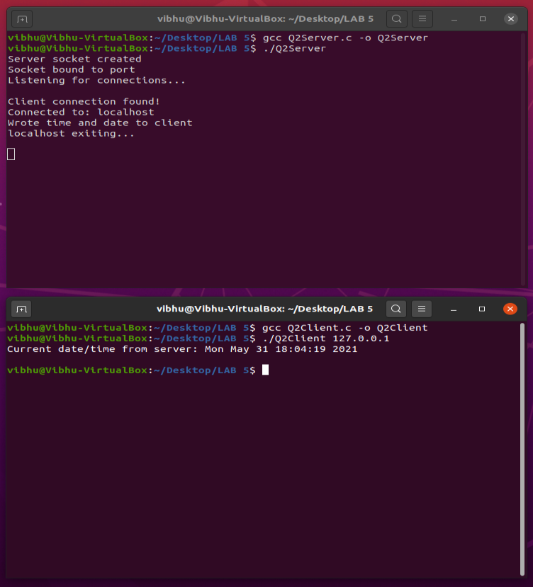

**Q3) Implement a message transfer from client to server and vice versa process using UDP.**

**Ans 3)**

**Aim:** To implement a message transfer from client to server and vice versa process using UDP.

**Algorithm:**

**Server Side Algorithm:**

STEP 1: Start

STEP 2: Declare the variables for the socket

STEP 3: Specify the family, protocol, IP address and port number

STEP 4: Create a socket using socket() function

STEP 5: Bind the IP address and Port number

STEP 6: Listen and accept the client’s request for the connection

STEP 7: Read the client’s message

STEP 8: Display the client’s message

STEP 9: Continue the chat

STEP 10: Terminate the chat

STEP 11: Close the socket

STEP 12: Stop

**Client Side Algorithm:**

STEP 1: Start

STEP 2: Declare the variables for the socket

STEP 3: Specify the family, protocol, IP address and port number

STEP 4: Create a socket using socket() function

STEP 5: Call the connect() function

STEP 6: Read the input message

STEP 7: Send the input message to the server

STEP 8: Display the server’s reply

STEP 9: Continue the chat

STEP 10: Terminate the chat

STEP 11: Close the socket

STEP 12: Stop

**Source Code:**

**Q3Server.c**

#include<stdio.h>

#include<netinet/in.h>

#include<sys/types.h>

#include<sys/socket.h>

#include<netdb.h>

#include<string.h>

#include<stdlib.h>

#define MAX 80

#define PORT 43454

#define SA **struct** sockaddr

**void** func(**int** sockfd)

{

**char** buff[MAX];

**int** n,clen;

**struct** sockaddr_in cli;

    clen=sizeof(cli);

    for(;;)

    {

        bzero(buff,MAX);

        recvfrom(sockfd,buff,sizeof(buff),0,(SA *)&cli,&clen);

        printf("From client" ,%s " To client:  ",buff);

        bzero(buff,MAX);

        n=0;

        while((buff[n++]=getchar())!='\n');

        sendto(sockfd,buff,sizeof(buff),0,(SA *)&cli,clen);

        if(strncmp("exit",buff,4)==0)

        {

            printf("Server Exit...\n");

            break;

        }

    }

}

**int** main()

{

**int** sockfd;

**struct** sockaddr_in servaddr;

    sockfd=socket(AF_INET,SOCK_DGRAM,0);

    if(sockfd==-1)

    {

        printf("socket creation failed...\n");

        exit(0);

    }

    else

    printf("Socket successfully created..\n");

    bzero(&servaddr,sizeof(servaddr));

    servaddr.sin_family=AF_INET;

    servaddr.sin_addr.s_addr=htonl(INADDR_ANY);

    servaddr.sin_port=htons(PORT);

    if((bind(sockfd,(SA *)&servaddr,sizeof(servaddr)))!=0)

    {

        printf("socket bind failed...\n");

        exit(0);

    }

    else

    printf("Socket successfully binded..\n");

    func(sockfd);

    close(sockfd);

}

**Q3Client.c**

#include<sys/socket.h>

#include<netdb.h>

#include<string.h>

#include<stdlib.h>

#include<stdio.h>

#define MAX 80

#define PORT 43454

#define SA **struct** sockaddr

**int** main()

{

**char** buff[MAX];

**int** sockfd,len,n;

**struct** sockaddr_in servaddr;

    sockfd=socket(AF_INET,SOCK_DGRAM,0);

    if(sockfd==-1)

    {

        printf("socket creation failed...\n");

        exit(0);

    }

    else

    printf("Socket successfully created..\n");

    bzero(&servaddr,sizeof(len));

    servaddr.sin_family=AF_INET;

    servaddr.sin_addr.s_addr=inet_addr("127.0.0.1");

    servaddr.sin_port=htons(PORT);

    len=sizeof(servaddr);

    for(;;)

    {

        printf("\nEnter string : ");

        n=0;

        while((buff[n++]=getchar())!='\n');

        sendto(sockfd,buff,sizeof(buff),0,(SA *)&servaddr,len);

        bzero(buff,sizeof(buff));

        recvfrom(sockfd,buff,sizeof(buff),0,(SA *)&servaddr,&len);

        printf("From Server : %s\n",buff);

        if(strncmp("exit",buff,4)==0)

        {

            printf("Client Exit...\n");

            break;

        }

    }

    close(sockfd);

}

**OUTPUT SCREENSHOTS:**

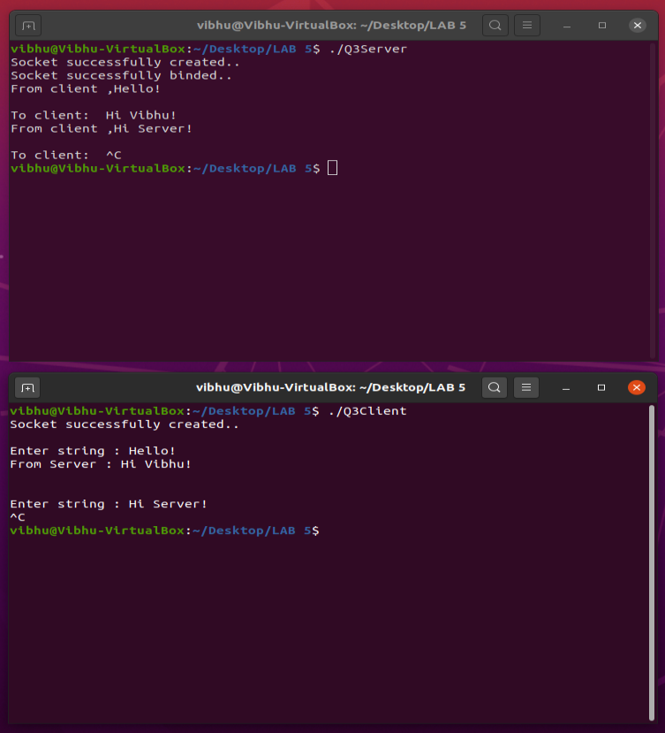

**Q4) Implement an Echo UDP server.**

**Ans 4)**

**Aim:** To implement an Echo UDP server.

**Algorithm:**

**Server Side Algorithm**

STEP 1: Start

STEP 2: Declare the variables for the socket

STEP 3: Specify the family, protocol, IP address and port number

STEP 4: Create a socket using socket() function

STEP 5: Bind the IP address and Port number

STEP 6: Listen and accept the client’s request for the connection

STEP 7: Read and Display the client’s message

STEP 8: Stop

**Client Side Algorithm**

STEP 1: Start

STEP 2: Declare the variables for the socket

STEP 3: Specify the family, protocol, IP address and port number

STEP 4: Create a socket using socket() function

STEP 5: Call the connect() function

STEP 6: Read the input message

STEP 7: Send the input message to the server

STEP 8: Display the server’s echo

STEP 9: Close the socket

STEP 10: Stop

**Source Code:**

**Q4Server.c**

#include<sys/types.h>

#include<sys/socket.h>

#include<netinet/in.h>

#include<unistd.h>

#include<netdb.h>

#include<stdio.h>

#include<string.h>

#include<arpa/inet.h>

#define MAXLINE 1024

**int** main(**int** argc,**char** **argv)

{

**int** sockfd;

**int** n;

    socklen_t len;

**char** msg[1024];

**struct** sockaddr_in servaddr,cliaddr;

    sockfd=socket(AF_INET,SOCK_DGRAM,0);

    bzero(&servaddr,sizeof(servaddr));

    servaddr.sin_family=AF_INET;

    servaddr.sin_addr.s_addr=INADDR_ANY;

    servaddr.sin_port=htons(5035);

    printf("\n\n Binded");

    bind(sockfd,(**struct** sockaddr*)&servaddr,sizeof(servaddr));

    printf("\n\n Listening...");

    for(;;)

    {

        printf("\n ");

        len=sizeof(cliaddr);

        n=recvfrom(sockfd,msg,MAXLINE,0,(**struct** sockaddr*)&cliaddr,&len);

        printf("\n Client's Message : %s\n",msg);

        if(n<6)

            perror("send error");

        sendto(sockfd,msg,n,0,(**struct** sockaddr*)&cliaddr,len);

    }

    return 0;

}

**Q4Client.c**

#include<sys/types.h>

#include<sys/socket.h>

#include<netinet/in.h>

#include<string.h>

#include<arpa/inet.h>

#include<string.h>

#include<arpa/inet.h>

#include<stdio.h>

#define MAXLINE 1024

**int** main(**int** argc,**char**\* argv**[]**)

{

**int** sockfd;

**int** n;

    socklen_t len;

**char** sendline[1024],recvline[1024];

**struct** sockaddr_in servaddr;

    strcpy(sendline,"");

    printf("\n Enter the message : ");

    scanf("%s",sendline);

    sockfd=socket(AF_INET,SOCK_DGRAM,0);

    bzero(&servaddr,sizeof(servaddr));

    servaddr.sin_family=AF_INET;

    servaddr.sin_addr.s_addr=inet_addr("127.0.0.1");

    servaddr.sin_port=htons(5035);

    connect(sockfd,(**struct** sockaddr*)&servaddr,sizeof(servaddr));

    len=sizeof(servaddr);

    sendto(sockfd,sendline,MAXLINE,0,(**struct** sockaddr*)&servaddr,len);

    n=recvfrom(sockfd,recvline,MAXLINE,0,NULL,NULL);

    recvline[n]=0;

    printf("\n Server's Echo : %s\n\n",recvline);

    return 0;

}

**OUTPUT SCREENSHOTS:**

